GEM Installation Guide

All documentation and programs that are included in GEM are copyright © 1995-2011 by Edward Barlow and SQL Technologies Inc. All rights are reserved.
Welcome To GEM – This Installation guide is designed to walk you through a complete installation. It is intended to contain everything you need to make your GEM rollout a success.

You should dedicate a server class machine as gem monitoring station. This can be a vm or blade. Space requirements are about 50gb disk drive and 4gb or more ram.

Unlike prior GEM versions which required a linux monitoring station to monitor linux/unix systems and linux/unix systems & databases, this version works from a single windows server. This server will run a web server (IIS), a database (Sql Server), and will run all GEM Batch Jobs.

The following screenshots are taken from an install on our standard platform, which currently is Windows Server 2008R2 with a Sql Server 2008R2 database.

Step 1: Download & Extract GEM

Download GEM
Select the following location in your web browser and download the file.
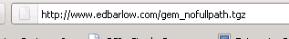

Extract GEM
Use a zip extractor to extract gem_nofullpath.tgz into C:/gem on your GEM monitoring system.
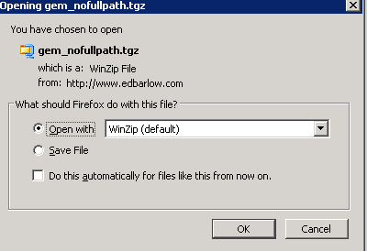
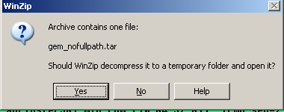

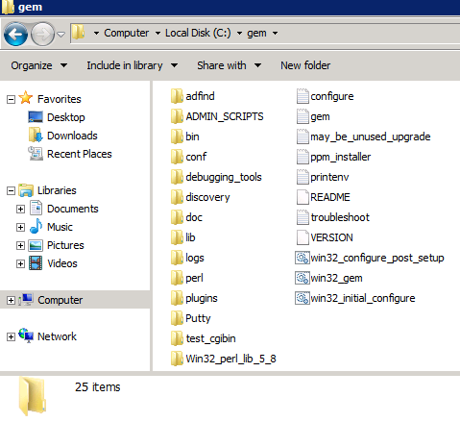

Check that the C:/gem directory looks like the screenshot at the left.

Step 2: Create gemalarms database

You should have a sql server setup on your monitoring system.

Connect to this database and run the following steps:

- Create A Database Named gemalarms
- Turn on simple recovery mode (optional for testing – you can tran dump it if you want)
- Create login named gemalarms with password gemalarms
- Add login gemalarms to database gemalarms with datareader/datawriter permission
- Your main monitoring account will need native authentication access to this database

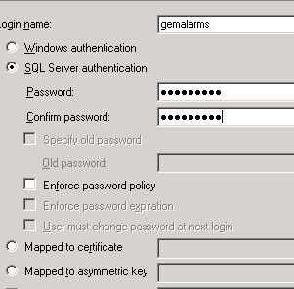
use master
go
CREATE LOGIN [gemalarms] WITH PASSWORD='gemalarms', DEFAULT_DATABASE=[gemalarms], CHECK_EXPIRATION=OFF, CHECK_POLICY=OFF
go
Create database gemalarms
Go
Alter database gemalarms set recovery simple
go
sp_dboption gemalarms,"select",true
go
sp_dboption gemalarms,"trunc",true
go
use gemalarms
go
checkpoint
go
sp_adduser gemalarms
go
EXEC sp_addrolemember 'db_datareader', 'gemalarms'
GO
EXEC sp_addrolemember 'db_datawriter', 'gemalarms'
GO

Step 3: Setup GEMDB ODBC DSN
Create an odbc setting for the GEM database and be sure to test connectivity. Call it GEMDB.
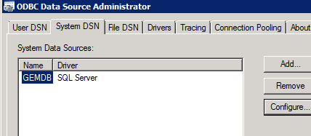
Fair warning, there are TWO odbc settings for x64 systems. This means you can add an odbc setting and it may not show up as a valid system for a 32 bit app. You need to use the 32 bit version. Drag and drop C:\windows\SysWOW64\odbcad32 to your desktop. And set up a System dsn from there.
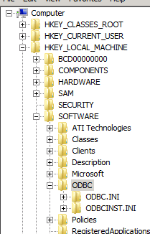
Test your data source.

Mass ODBC Setup: For After you set up your GEM password file
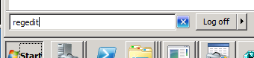
The following should be done AFTER you setup your password file. GEM is written in perl/DBI which requires ODBC DSN’s for all monitored systems. This can require multiple hundreds of DSN’s in a large environment. You do NOT need to create DSNs by hand. Once you have set up a Sql Server (and optionally a sybase) DSN, they can be replicated using Regedit!
Start -> Run -> Regedit
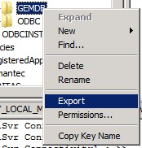
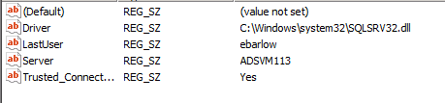
Find the DSN entry you wish to replicate. It will be in the location noted above if you are using an x64 architecture. Once you find the entry, right click on the sql server DSN (GEMDB) and export it to C:\gem\bin\sqlsvr.reg
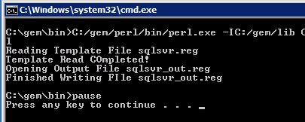
If you use sybase ASE, create an odbc DSN using the odbc manager and then export it to C:\gem\bin\sybase.reg. To create a sybase DSN, you will need working Sybase Open Client Software and to setup your sql.ini file using the open client directory service editor tool.

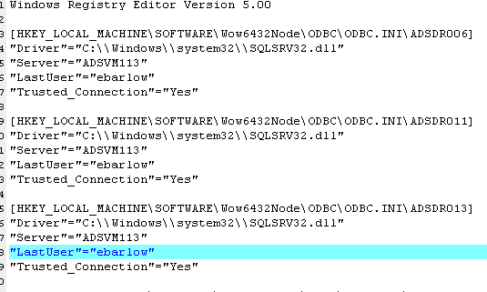
Doubleclick on C:/gem/bin/duplicate_registry.bat and it will convert the sqlsvr.reg to sqlsvr_out.reg with all your servers in it and will convert sybase.reg to sybase_out.reg with appropriately mapped hostnames and ports from your sql.ini file.

Be sure to EDIT the output registry before you double click it! Then double click the sqlsvr_out.reg and sybase_out.reg files, and confirm yes to add these values to your registry.

Test the DSNs you just created

THE PRE INSTALLATION CHECKLIST
The following checklists are designed to speed you through the installation.

- GEM Administrator Email:
- Windows Monitoring System

- Install Native Client Database Tools
  - sql server
  - sybase
  - mysql
  - oracle
- Download & Install Software into C: (step 1)
- Setup IIS (step 2)
- Setup Monitoring Database (step 3)
- Setup ODBC DSN’s For Monitoring Databases
- Native No-Password ssh Setup To Any UNIX Systems To Be Monitored

- GEM Home Directory
GEM DATABASE DEFINITION | YOUR VALUE
Database Server Name
Create gemalarms Database | DONE / NOT DONE
Create gemalarms login | DONE / NOT DONE
Make gemalarms a datareader & datawriter | DONE / NOT DONE
- Database Server For Monitoring
- Native Authentication Required For Sql Server, sa for Sybase
- Windows IIS Web Server
VARIABLE | EXAMPLE | YOUR VALUE
Web Server Name | SERVER123
Full Path Spec To cgi-bin | //server123/c$/cgi-bin
URL for this directory | http://server123/
Copy test_web_script.pl
Test using test_web_script.pl

- Win32 Login For Scheduled Tasks
[ this login must be able to use native authentication to your win32 servers ]

SERVERS TO MONITOR CHECKLIST
We recommend a trial instal on 4-6 database servers on 4-6 separate systems.
You will require the following rights on these database servers:
Sql Server: You need native authentication using an account with VIEW_SERVER_STATE
Windows Hosts: You need Windows administrator access your Windows database servers in order to monitor disk space and event logs.
Sybase: You will require sa_role access for all your Sybase database servers to install the stored procedure library. You can use a non-sa access for monitoring.
Unix: requires "no-password" access via ssh for your Unix systems for access to log files. Requires sybase Unix account access for your Sybase database servers to read sybase event logs
DB SERVER | SA CREDENTIAL | HostName | ODBC SETUP?

UNIX/LINUX HOSTNAME | CREDENTIAL | NO PASSWORD SSH?

WINDOWS HOSTNAME | ADMIN CREDENTIAL | TESTED?

Step 4 – IIS Web Server Setup

GEM Requires a functioning IIS web server on your monitoring system.
Complete IIS 6 and IIS 7 setup instructions are attached at the end of this document as APPENDIX 1.
Once you have configured IIS , you need to test that it is functioning appropriately

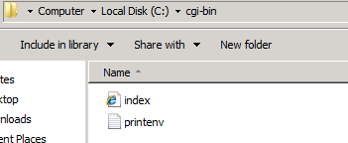
copy C:/gem/test_cgibin to C:/cgi-bin

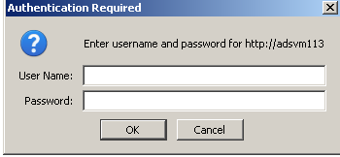
Step 4 – part 2: Go To @ http://hostname/
You will receive a password dialog when you connect to your web site and then should receive an IIS splash screen.

Browse to http://<your web server>/index.htm
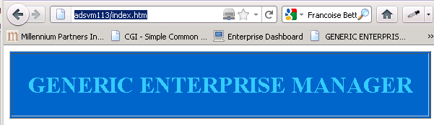
This verifies that your page can handle static files
Browse to http://<your web server>/printenv.pl to see a page like
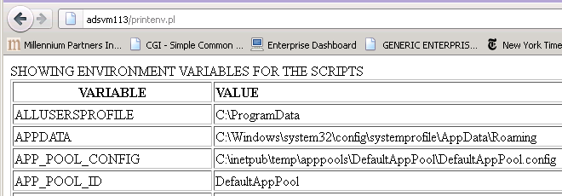
This verifies that perl is working.

Step 5 – Checklist

Initial Configuration Checklist: win32_initial_configure.bat
Run Through Initial Steps And Start bin/configure.pl Application
Agree With The License
Register Your Install (Actual Registration WILL Fail)
Sybase Home Directories (Ignore On Windows Sybase)
Password Vault (Ignore)
Mail Setup - Set SMTP Host and Test Mail To GEM Administrator EMAIL
Enter Database Info & Install/Upgrade Alarm Database. Check Background Screen For Errors
Validate Alarm Database
Deploy The Web Scripts To The Web Server
Configure Win32 Monitor Station
Manually Verify Installation
Close the Application Using the Close Button - Do not X out of it.

Step 5 – Initial Configuration Process – win32_initial_configure.bat
Run win32_initial_configure.bat to set things up. Click on win32_initial_configure.bat.
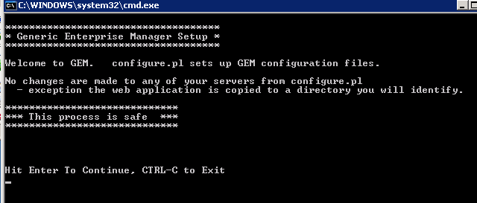
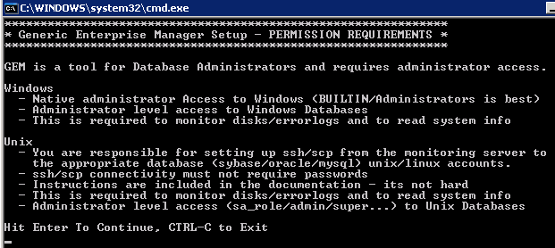
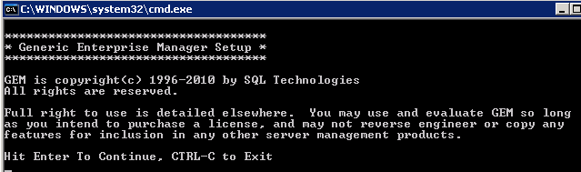
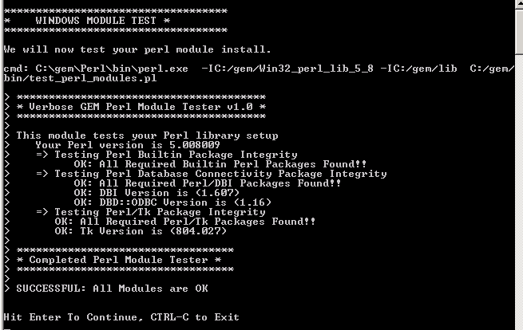
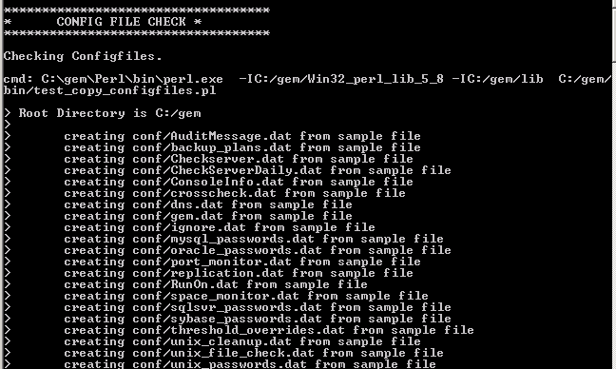
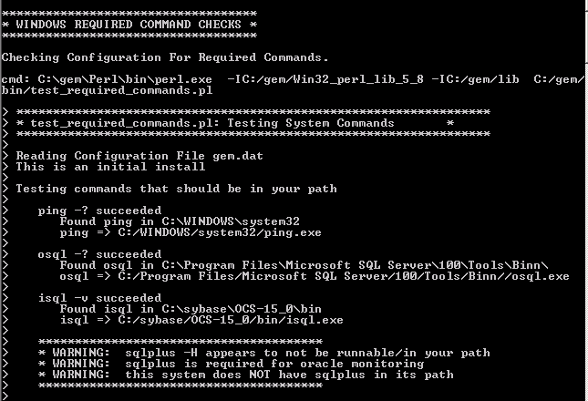
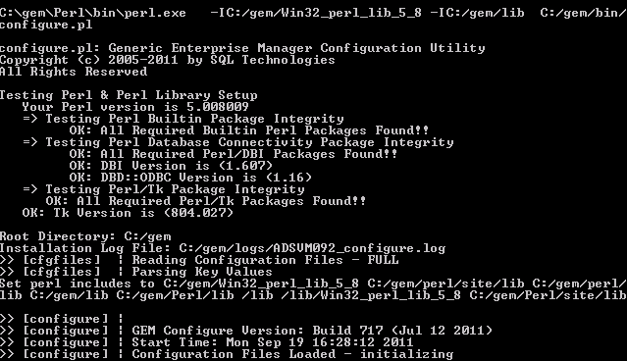

Tab 1: Welcome Tab
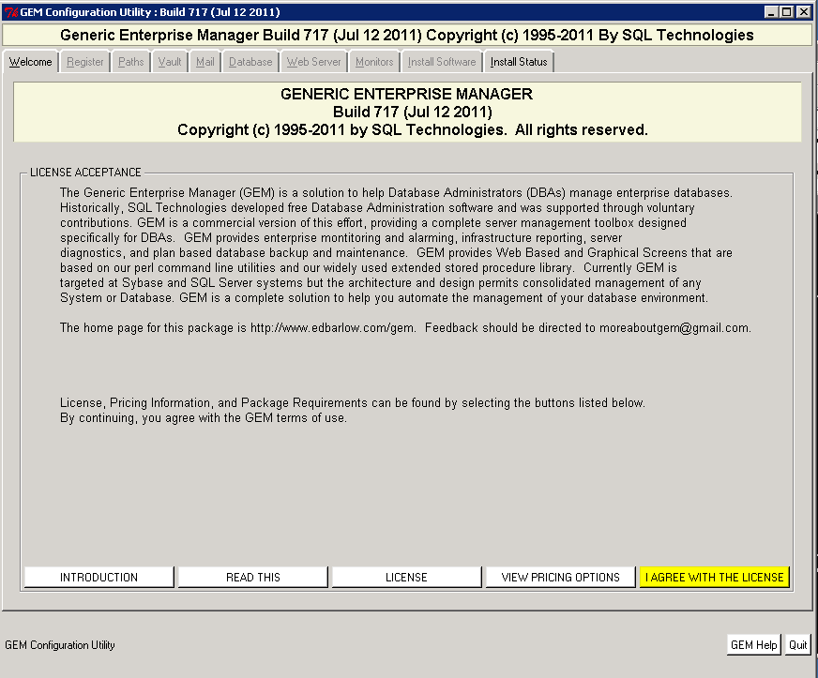
You will need to select I AGREE WITH THE LICENSE

Tab 2: Registration Tab
Enter your Name, Company, Your Mail, Environment on the Products on Registration Tab
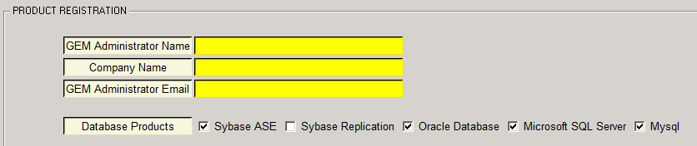

Tab 3: Mail Tab
Enter your smtp mail host and Click Win32 Test Mail Install to test mail. You should receive a mail.
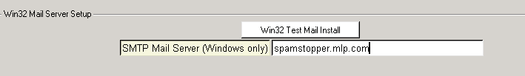
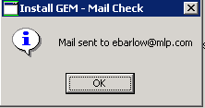
You should receive a mail and the following popup.

Tab 4: Install The Database Objects
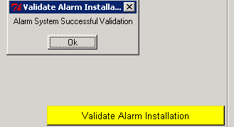
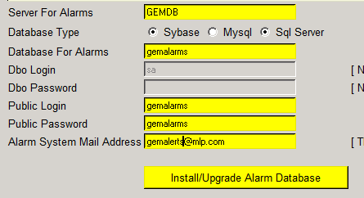
Choose GEMDB, enter the data for the monitoring database,
Click the Install/Upgrade Alarm Database and Validate Alarm Installation

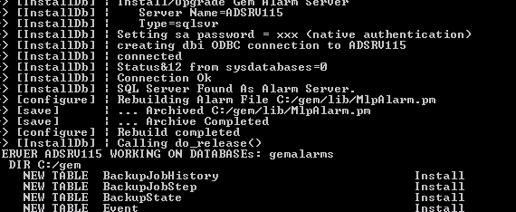
Review the background tab (the dos window with the ascii messages) to ensure that all is well.

Note: If you can not connect on an x64 systems, check that the GEMDB dsn is configured in C:\windows\SysWOW64. You can not use 64 bit DSNs with 32 bit perl.
If, by chance you get this ->
Rename C:/gem to C:/gem.bad, and then Copy C:/gem.bad to C:/gem. This will reset errant file permissions - can happen if you install over the net.

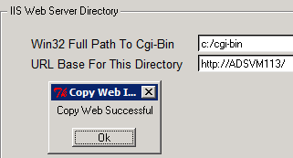
Tab 5: Web Server Tab
Enter the path & url for the web server virtual directory. The documentation says to use a Full Path url – but because we are on the web server, you can enter c:/cgi-bin as the full path. This directory must exist and be writable. The background screen will indicate that all was copied
Now you Copy Code to Web Server.
Select AutoVerify Your Server
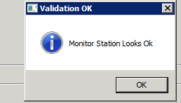

Tab 6: Configure Win32 Monitor Station
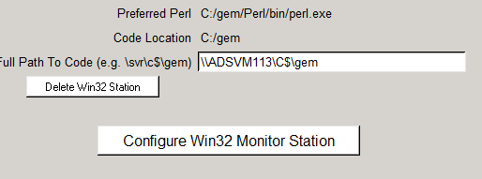

Tab 7: Install Software
Click to Manually Verify the Installation is Functioning.

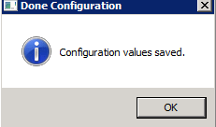

You should now Quit configure.pl to save the work you have just completed.

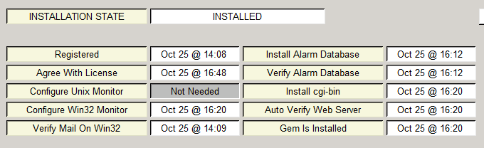

Step 6 – Setup Configuration Files
GEM is a simple script based monitoring and reporting system. It is based on configuration files. The most important configuration files are your password files, which define your universe of monitored systems. Your configuration files are stored in C:/gem/conf. All configuration and password files are documented at the top of the file. Password files are distributed as *.dat.sample files, and the configuration process creates a .dat file from the template only if no .dat file exists. This ensures safety during upgrades because you can not overwrite your configuration data.

Configuration Files You MUST Edit

Edit / Setup the GEM Master Configuration File - gem.dat
gem.dat is the main configuration file for the system. This file is managed by the configure.pl application. You should at this point hand edit gem.pl and change only the following items:

GEM_ADMINISTRATOR_LOGIN = ebarlow
COMPANYKEY = MyCompanyName

Pick your own COMPANYKEY (no spaces). If you understand your active directory categorizations, you can adjust these two lines so that you can import your active directory servers, users, and groups.

ADFIND_OPTIONS = -b ou=AD_Servers,dc=AD,dc=MLP,dc=COM -f "(objectCategory=computer)"
ADFIND_OPTIONS = -b dc=AD,dc=MLP,dc=COM -f "(objectCategory=group)"

You may wish toalter the list of windows services that are monitored if you are monitoring another type of database (say sybase on windows):
ALERTABLE_WIN_SERVICE_NAMES = 'MSSQLSERVER, SQLSERVERAGENT, SQLBrowser, msftesql, MsDtsServer, ReportServer, TermService,W32Time,Eventlog,CqMgHost,CpqNicMgmt, CqMgServ,CqMgStor,SQLBackupAgent

Edit / Setup Your Password Files
The hand editable password files are located in the conf subdirectory and are named sybase_passwords.dat, oracle_password.dat, win32_password.dat, unix_passwords.dat, sqlsvr_password.dat. If you add new databases or systems, you need to run gem.pl to Load Configfiles To Database, and may wish to recreate & reschedule your Batch Scripts.

Password File Format:
System_name login password
<tab/space>KEY=VALUE

Password File Keys:
- SERVER_TYPE=[PRODUCTION|DEVELOPMENT|DR|QA]
- SYBASE=<sybase home directory> only for unix
- IS_MONITORED=Y/N only for sybase
- DESCRIPTION=description only for sybase
- For sql servers using native authentication use ‘native’ for login & password
- ERRORLOG==<path to file on hostname> only for sybase
- BACKUPSERVERLOG==<path to file on hostname> only for sybase
- MNEUMONIC=<Short Descripton> for win32 & sqlsvr
- DISKS=C$ D$ for win32 – not sure it is used for anything

Example Lines From Windows Password File
PRSRV074
DISKS=C$ D$
SERVER_TYPE=PRODUCTION
DRSRV222
DISKS=C$ D$ E$
SERVER_TYPE=DR
PRCLUSTER202
DISKS=C$
IS_CLUSTERNODE=Y
SERVER_TYPE=PRODUCTION
PRCLUSTER201
DISKS=C$
IS_CLUSTERNODE=Y
SERVER_TYPE=PRODUCTION
SQLCLUSTER1
DISKS=D$ E$ L$ S$
IS_CLUSTER=Y
SERVER_TYPE=PRODUCTION

Example Lines From Unix Password File
productionsyb sybase sybpass123
SERVER_TYPE=PRODUCTION
UNIX_COMM_METHOD=SSH
WIN32_COMM_METHOD=SSH
SYBASE=/export/home/sybase
-or-
productionsyb sybase sybpass123
SERVER_TYPE=PRODUCTION

Example Lines From Sybase Password File
GLOBALDB sa password1
SERVERNAME= GLOBALDB
SERVER_TYPE=PRODUCTION
PORTNUMBER=5000
HOSTNAME=globaldb
ERRORLOG=/export/home/sybase/ASE-12_5/install/GLOBALDB.log
BACKUPSERVERLOG=/export/home/sybase/ASE-12_5/install/GLOBALDB_BACK.log

Example Lines From Sql Server Password File
DRSRV026 native native
SERVER_TYPE=DR
HOSTNAME= DRSRV026
PRSRV030 native native
SERVER_TYPE=PRODUTION
HOSTNAME= PRSRV030
MNEUMONIC=PRODUCTION-TWO
PRODONE native native
SERVER_TYPE=DEVELOPMENT
HOSTNAME=ADSRV034
MNEUMONIC=PRODUCTION-ONE

Configuration Files to Edit After the Installation Is Complete

Backup Plans - backup_plans.dat [SKIP]
backup_plans.dat is the master configuration file for the GEM backup scripts.
This file is documented separately and need not be edited.

Directory Cleaner – win32_cleanup.dat, unix_cleanup.dat [SKIP]
[SKIP] The directory cleaner configuration files automate disk management for you.
The file conf/win32_cleanup.dat and conf/unix_cleanup.dat contains a list of disk space Cleanup instructions. Customize this file to include your tran/archive log directories, your application log directories, and any other directories that fill up on your systems. A best practice is to add rows to this file over time, every time you spots directories that get big.
The lines in this file conform to the arguments of ADMIN_SCRIPTS/bin/purge_old_files.pl
--host=<host> hostname (only for unix)
--hours=<hours> keep time for files
--days=<days> keep time for files
--dir=<dir> directory
--versions=num versions of the file to keep
[--del] - do you wish to delete the file?
[--done] - only work on files with .done extension

This flexible language allows you to pick a retention plan for files in, say, a log shipping directory and have a backstop for the files removal. You may occasionally have backup directories where the files don’t delete correctly. You specify a hostname (unix) and directory (full path url if win32). You then can check for number of versions or retention time (--days)

First example keeps three versions of each database backup. Second keeps 2 days:
--dir=//hostname/d$/backups –del –-versions=3
--dir=//hostname/d$/backups –del –-days=2

On unix, just add a host attribute and normal directory structure name.

File Checker - Win32_file_check.dat and Unix_file_check.dat [SKIP]
Our file existence checker uses the same format as the file cleanup routine. The following directives alert unless at least one backup for each database exists from within the past 3 days.

--DIR=//sqlprod1/d$/dump --DAYS=3 --FILE=gemdb_db_.BAK
--DIR=//sqlprod1/e$/backups/ --DAYS=3 --FILE=BROKERSQL.MYDB.dbdump..
--DIR=/user/local/backups --DAYS=3 --FILE=BROKERSQL.MYDB.dbdump.. –host=gemserver
The first example detects that a native backup scripts sql server backup for gemdb exists within 3 days. The second looks for backup files created by the GEM backup scripts. The last looks on a unix host. Numbers are removed from the –FILE argument i.e. - dates are skipped. This file can be autogenerated BUT I FORGET HOW.

Port Monitor – port_monitor.dat [ Automatically Created By gem.pl ]
Port Monitoring is a quick availability test - and a good way to find out if a database or system is down. The file conf/port_monitor.dat contains a list of Hosts and Ports to Monitor.
This file is auto generated by gem.pl with “Create Port Monitor File”
Simple format:
# hostname PORT SERVER DESCRIPTION
SRVR001 1433 SRVR001 Microsoft SQL Server
SRVR007 1433 SRVR007 Microsoft SQL Server
brokersql 1433 BROKERSQL Microsoft SQL Server
mail1 25 Sendmail on mail1

The create port monitor option scans your interfaces file and gem configuration files and creates the configuration file. Rather than deleting from this file, comment out the line (with a #) – there is a batch job that rebuilds this file weekly and it understands commented out services.

Windows Service Monitoring – win32_service.dat [ Automatically Created By gem.pl ]
Important Services on windows are monitored. The list of what to monitor is generated by gem.pl. The win32_service file operates the same ways as does port monitoring in that you should comment out lines with a # instead of deleting them.

The list of services monitored can be altered in gem.dat [ what are the sybase service names ]

Log shipping and backup monitoring – crosscheck.dat [ Postpone ]
The crosscheck.dat file is used by the Backup Checker and DR Monitoring systems. It allows you to define what systems are replicated, copied or log shipped to each other

Sybase Replication Monitoring – replication.dat [ Postpone ]
The File conf/Replication.dat is used by the Sybase replication server monitoring scripts and will need to be populated with your Rep Servers and Routes.
# REPSERVER $NAME $LOGIN $PASSWORD $THRESHOLD_MB
# REPROUTE $SOURCE_SVR $SOURCE_DB $DEST_SVR $DEST_DB $REPSERVER
#
# EXAMPLES (350MB Thresholds):
#
# REPSERVER REP1DR_RS sa <pass> 350
# REPSERVER REP2_RS sa <pass> 350
# REPSERVER REP1_RS sa <pass> 350
#
# REPROUTE SYB1 my_db SYB2 my_db REP2_RS
# REPROUTE SYB1 my_db SYB1DR my_db REP2_RS
#
# ONCE YOU SET THIS FILE UP - PLEASE RUN
# ADMIN_SCRIPTS/monitoring/SybRepMonitor.pl --ACTION=INSTALL
# MONITORING IS HANDLED AUTOMATICALLY BY THE GEM BATCH SybRepMonAgent
There are two programs that check replication. The batch SybRepServerChecker will check all your rep servers to be sure that no routes are suspended, that disk space is reasonable, and that there are no other serious errors. There are also three batches, SybRepMonAgent, SybRepMonCheck, and SybRepMonReport that compute latencies of your replication, and will warn you when replication falls behind. These three batch programs call SybRepMonitor.pl. This program takes an argument --ACTION.
To initialize this system, you need to set up your configuration file and then run
C:/gem/perl/bin/perl.exe SybRepMonitor.pl --ACTION=INSTALL

Diskspace Alarm Thresholds – threshold_overrides.dat [ Postpone ]
Threshold_overrides.dat sets space monitoring thresholds for Unix, Windows, and Sybase space monitoring. You will probably want to adjust this file as the result of monitoring alerts from your system, not in your initial configuration file edits.
Generally speaking, this is most needed when some resource is nearing "full" and generating alarms, but you can not fix the problem immediately - intending to fix the problem later. The conf/threshold_overrides.dat file allows you that control.

Step 6c - Do Not Edit These Files
AuditMessage.dat win32_backupdirs.dat
Password_vault.dat win32_clusternodes.dat
Jobscheduler.dat CheckServerDaily.dat
Console.dat Ignore.dat
Dns.dat Space_monitor.dat

Step 7 - No Password SSH Setup (only if linux or unix involved)
No password ssh access is required to monitor Databases and Systems that are hosted on Linux or Unix
A copy of the putty ssh clients ships with GEM in C:/gem/putty
An awesome article on how to set up putty no password ssh is at
http://unixwiz.net/techtips/putty-openssh.html
Essentially you will need to
- Run puTTYgen to create a key
- Save a public/private key into C:/gem/putty
- Copy the public key from the Putty Key Generator screen into the authorized_keys2 file in your .ssh directory.
- Run Pagent and save the keys so your batch jobs work
If ssh connectivity does not work, it is likely a permission issue. Make sure your unix/linux home directory is not group/world writable, that your .ssh tree has 700 permissions
chmod –R 700 .ssh
chmod go-w

Step 8 -The gem.pl Checklist
Test - Mail Setup
Test - Send a Test Alert
(Unneeded) Tools - Reformat Code line
Tools - Load Configfiles to Database
Tools - Create Port Monitor File - to set up port_monitor.dat
Tools - Snapshot Win32 Services - to set up win32_service.dat
Tools - Load Stored Procedures - Sql Servers
Tools - Load Stored Procedures - Sybase
Batch Jobs - Create Win32 GEM Batch Jobs
Batch Jobs - Schedule Win32 Batch Jobs
Load static data
Optional Configuration Directory in $GEM/conf
Edit Checkserver.dat to Set Specific Overrides for Checkserver.pl Program
Edit win32_file_check.dat to set directives for checking critical file existence on win32 drives.
Edit unix_file_check.dat to set directives for checking critical file existence on UNIX drives.
Edit win32_cleanup.dat to define directives for cleaning up win32 drives.
Edit unix_cleanup.dat to set directives for cleaning up UNIX drives.
Edit replication.dat to set up replication monitoring
Edit threshold_overrides.dat to set up disk monitoring thresholds
Edit crosscheck.dat to set up no backup alarm thresholds

Step 8 – win32_gem.bat - Configuration Finalization & Testing
GEM offers a simple ASCII GUI for post installation tasks. This utility will run tasks that you might want to repeatedly run after an installation. For example, every time you add a server, you should rebuild your batch scripts and reschedule them - because the tasks are customized to your list of servers.
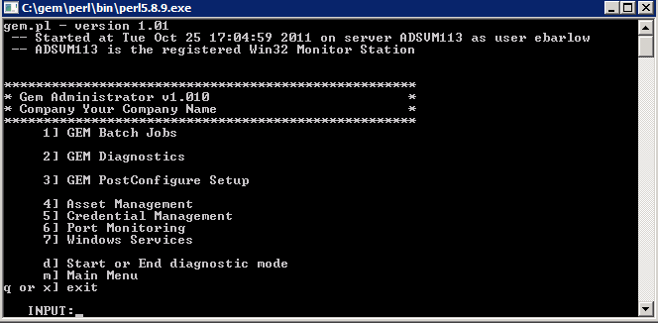
Execute C:/gem/win32_gem.bat by double clicking on the batch file.
It should NOT say “Your Company Name” -> edit conf/gem.dat and change the COMPANYKEY key.
This simple gui will help you manage your GEM Installation.

Gem Diagnostics
For now, focus on GEM Diagnostics. You have set up you’re your password files prior to continuing. The first task is to check that you have appropriate access rights to your monitored servers.
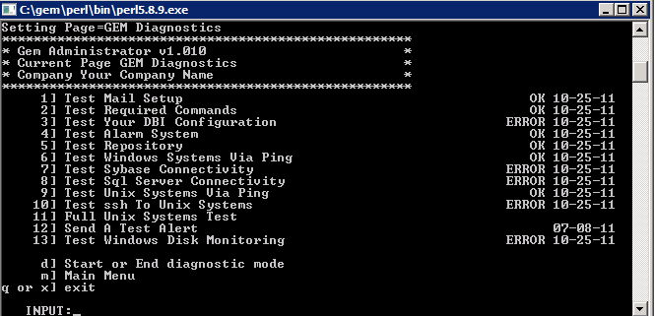
Move through these tests in order and correct any problems that are found (missing dsn’s, invalid connection strings, etc). One common problem is that dns name resolution may not be set up for your domain – contact your adminstrators if you get a valid response from ping hostname.xyz.com but not via ping hostname.
The gem.l menu system is designed to simplfy your administration. Note the status & date items are controlled by the returned text from the underlying programs.
If you wish to see what is happening in more detail, run the menu items in diagnostic mode.

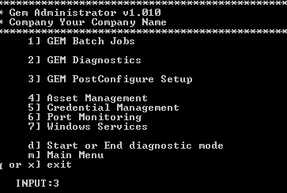
Post Configure Setup
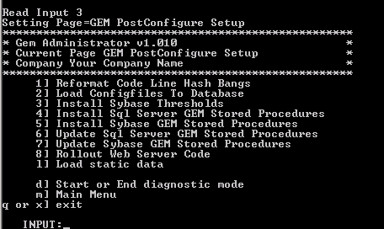
Once you have succeeded in ensuring that all the main operations required by GEM are functioning, you should head to Gem Post Configure Setup
From here, you will want to run the items.
You need to run
- Load Configfiles To Database
- Install Sybase Thresholds
- Install *** GEM Stored Procedures
- Load Static Data

Asset Management and Credential Management
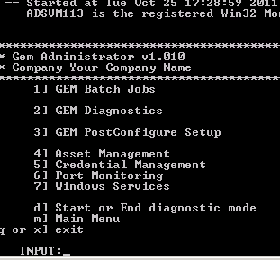
These are two modules you may not wish to use unless you wish additional setup. If you get the feeds working, they provide you a complete asset / credential management system.

Setup Port Monitoring

Select Port Monitoring and set up your port_monitor.dat configuration file via Create Port Monitor File and then Run Port Monitor to test

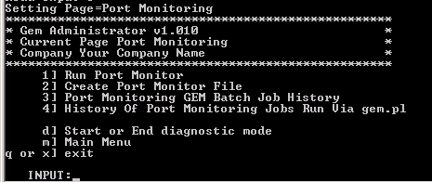
Setup Windows Services
Do the same for Windows Service Monitoring.
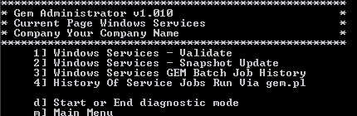
If you find services/ports that are bad and that you do not wish to monitor, do NOT delete them from the configuration files. You should comment them out with a “#”.

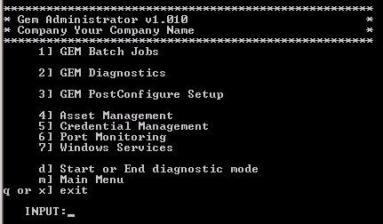
You have completed diagnostics and Post Configure Setup. Be sure to understand any problems before moving on!

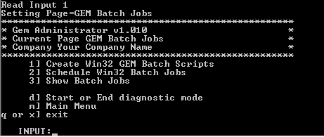
Create Win32 GEM Batch Jobs

Schedule Win32 GEM Batch Jobs

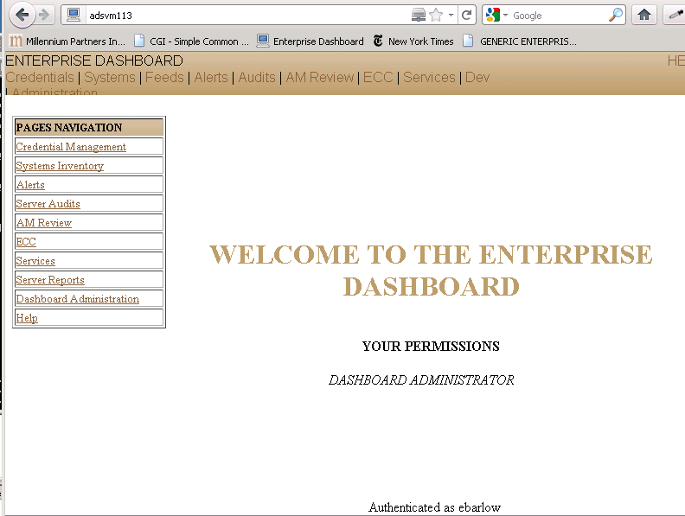
Brows to your web server and select Alerts
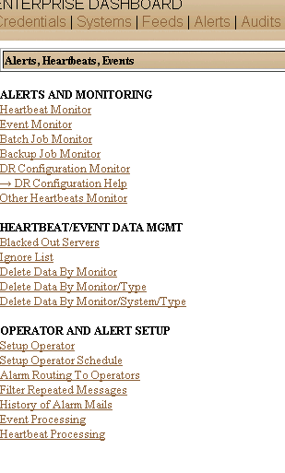
Select Setup Operator
Make yourself our your team Operators

Now Go to “Alarm Routing To Operators” and add yourself for Errors and
Worse.

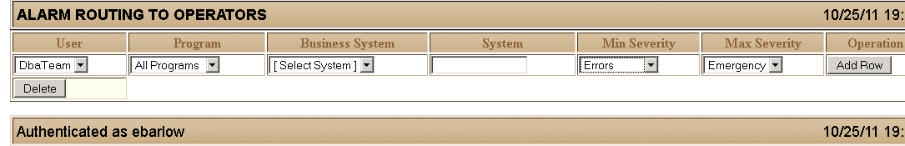
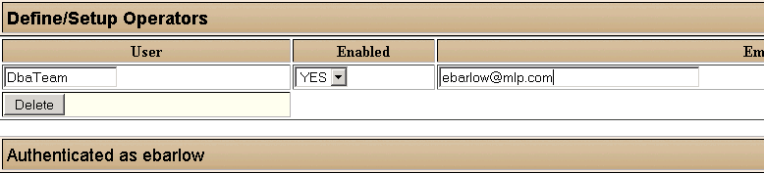

Other Miscellaneous Notes

Notes on the sybase threshold manager [Option On gem.pl ]
The Sybase threshold manager (ADMIN_SCRIPTS/bin/threshold_manager.pl) installs customized sp_thresholdaction procedures into your databases. The purpose of these is to track and warn you when you when transaction logs grow to much. Each sp_thresholdaction procedure will write to a small to a table in sybsystemprocs when triggered. A second program watches this file and alerts you when thresholds are passed – allowing you to proactively manage your sybase log segments by expanding capacity before they fill up.
The Threshold manager reinstall batch script runs ADMIN_SCRIPTS/bin/threshold_manager.pl --ACTION=INSTALL
One warning. If you increase the *size* of any of your databases, you will need to rerun the above installation command. Sybase thresholds are based on free pages and the percentages are therefore set when you run the installation. So, if you double the size of a database, your 60% threshold will be firing at 30% and recording it as 60% full! Just reinstall and you will be ok!.
Other commands of interest:
ADMIN_SCRIPTS/bin/threshold_manager.pl --ACTION=CHECK
ADMIN_SCRIPTS/bin/threshold_manager.pl --ACTION=REPORT
This feature only works with Sybase

Monitoring your own scheduled tasks
You can use GEM to alert on the output of your. Our convention is for scripts to redirect standard output to files with a .out extension, and for standard error to go to.err extension files in data/cronlogs directories directory. Alerts will be generated if .err files exist with > 0 size.
script.pl > C:/gem/data/cronlogs/script.out 2> C:/gem/data/cronlogs/script.err

HOW TO UPGRADE
Gem ships with a fully documented code line – and a clear separation of data and code lines. The only data stored in other than in the ‘data’ tree are the password files, and the code line ships with files ending in .sample which overwrite the ‘password’ and ‘configuration’ files only if they do not exist. You can extract the code line on top of your existing code line with no ill effects. After you upgrade GEM, you should rebuild and reschedule your GEM batch jobs if so instructed by GEM Tool Support.

Directory security
GEM is an administrative tool, designed for system administrators. As such, the conf directory contains all your passwords. You need to protect this data via operating system permissions.

APPENDIX 1 - IIS 7 SETUP (Use on IIS 7 Only)
IIS 7 has a completely different setup. Here is what I do from an empty / clean install.
Bring up IIS manager from Start->Programs->Administrative Tools->IIS Manager
Change the default physical path
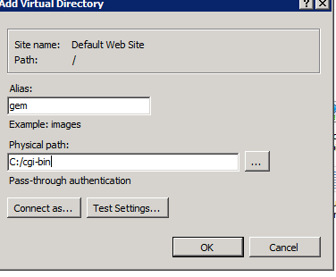
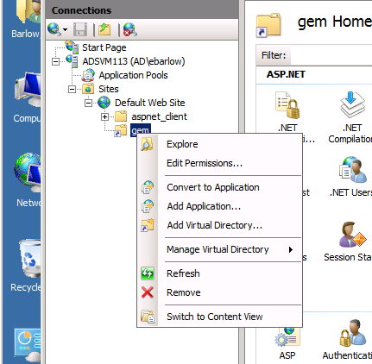
Set 32 Bit Applications On
Copied from : http://blogs.iis.net/wadeh/archive/2009/04/13/running-perl-on-iis-7.aspx
If you are running the 64 bit version of Windows 2008, ensure that your application pool is configured to run as 32 bit. Assuming that you will be using ActivePerl in the default application pool, these steps will do it:
      - From the Windows 'Start' menu, pick run and type "inetmgr" (without the quotes). Click on 'OK".
      - In the left hand pane, open up the settings for your server. Click "Application Pools".
      - In the Application Pools page, select "DefaultAppPool".
      - In the right hand pane, under "Edit Application Pool", click on "Advance Settings..."
      - In the Advanced Settings dialog, ensure that "Enable 32-bit Applications" is set to "True".
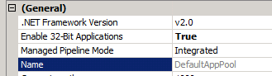
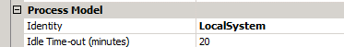

Recycling Conditions -> pick 8Pm for specific time and add Memory Based Max if you desire.

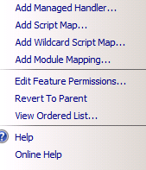
Create a script map that associates "*.pl" requests with perl
      - In the left hand pane of IIS Manager, select your server.
      - In the center pane, double click on the Handler Mappings icon.
      - When the Handler Mappings pane is displayed, click on the "Add Script Map" item in the Actions pane on the right.
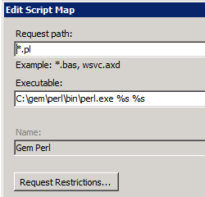
Enter Data Exactly as Per Screen At Left
For Module, select "IsapiModule" from the dropdown list. Note that the ISAPI module is a prerequisite. If it does not show up on this list, it will need to be installed an an IIS optional component.

You do not need to do anything with the "Request Restrictions..." button.

Authentication

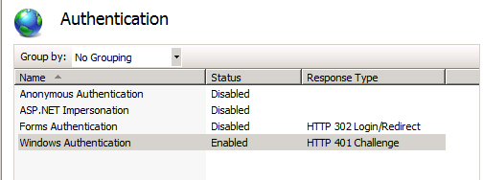

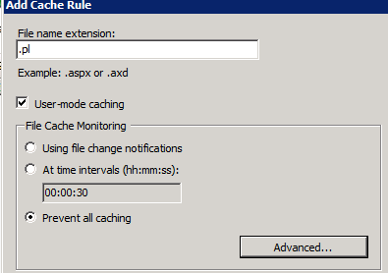
Output Caching
To setup output caching click on Default Web Site -> and Output (under IIS) in the Default View
Click Add
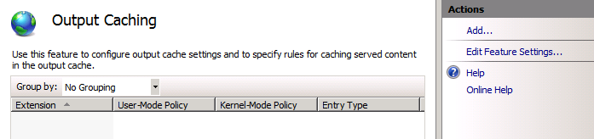

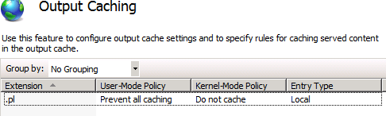

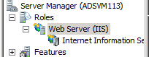
More Services Adjustments
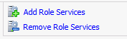
Using the server manager, select your IIS server and click Add Role Services (all the way on the right, may have to scroll down). Select Application Development (CGI) and Health & Diagnostics (Tracing)

Failed Request tracing
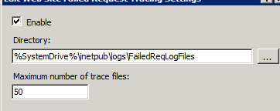
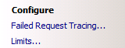
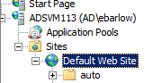

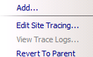
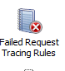
Define Some Rules

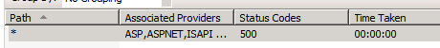
You can browse your logs in the appropriate location

APPENDIX 2 - IIS 6 SETUP (Use on IIS 6 Only)
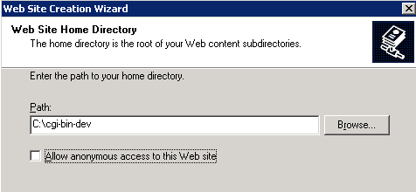
You need to set up your web site with a directory that is script enabled. To do this, “My Computer”-> Manage-> and find the IIS toolbar. Create a new web site using the following screeshots for help.
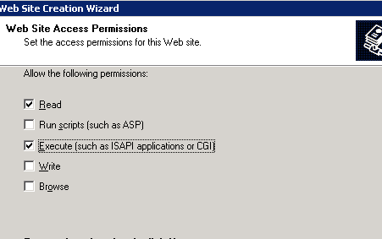
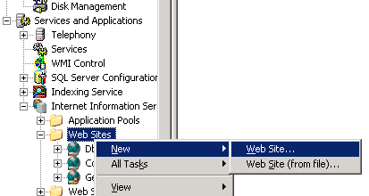
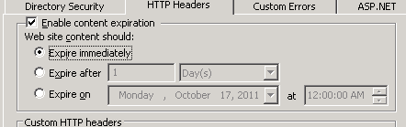
Be sure to add Index.html as a legal default page and
enable Content Expiration
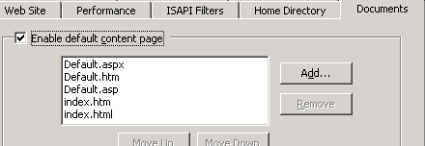
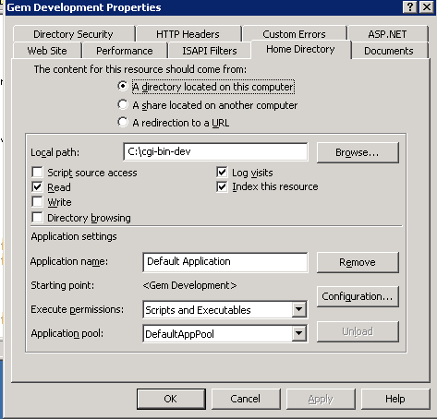

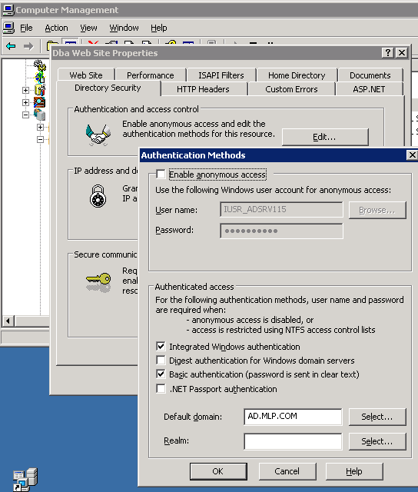
You are going to want to test your install. The best way to test your IIS install is to test with the program printenv.pl from the GEM installation.

This will be done at a later step.

There are more iis 6 installation screenshoots in C:/gem/doc/IIS_INSTALLATION

